BIOLOGY DEPT
NAMUNGOONA SALAF SEC.SCHOOL
Transport in Animals

1. The table below shows the volume of blood in a woman's left ventricle at different times during one second

Time (seconds) | Volume of blood in left ventricle (cm³)
0.0 | 112
0.1 | 120
0.2 | 95
0.3 | 65
0.4 | 50
0.5 | 55
0.6 | 82
0.7 | 90
0.8 | 100
0.9 | 112
1.0 | 120

a) Plot a graph to represent the information in the table (07mrks)


b) Explain the changes in the volume of blood in a woman's left ventricle (08mrks)
................................................................................................................................
...............................................................................................................................
................................................................................................................................
...............................................................................................................................
................................................................................................................................
...............................................................................................................................
c) Outline two characteristics of blood moving out from the left ventricle (02mrks)
................................................................................................................................
...............................................................................................................................
d) How does the body of a mammal benefit from the blood circulation (03mrks)
................................................................................................................................
...............................................................................................................................
................................................................................................................................
...............................................................................................................................
2. The graphs below show the variation of the pressure of the flow of blood in a mammal in two different blood vessels A and B within a period of 60s

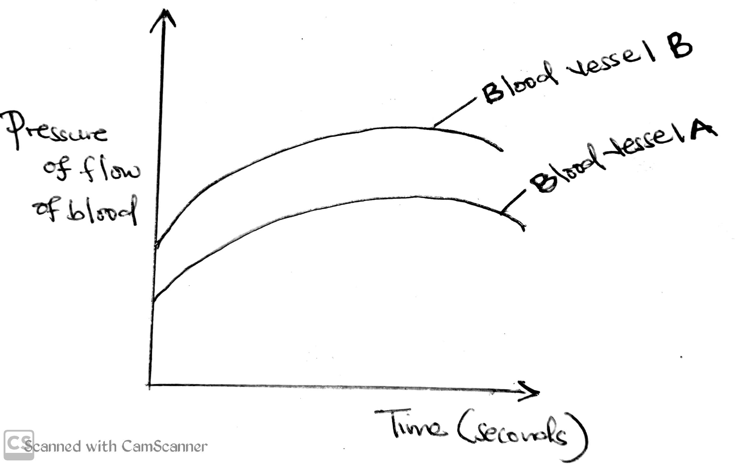
a) From the graph, with a reason suggest the possible identity for
i) Blood vessel A (01mrk)
................................................................................................................................
...............................................................................................................................
Reason (01mrk)
................................................................................................................................
...............................................................................................................................
ii) Blood vessel B (01mrk)
................................................................................................................................
...............................................................................................................................
Reason (01mrk)
................................................................................................................................
...............................................................................................................................
b) In thr space provided below draw and show the lumen of each blood vessel only (02mrks)
................................................................................................................................
...............................................................................................................................
................................................................................................................................
...............................................................................................................................
c) State 2 structural differences between Blood vessel A and B (02mrks)
................................................................................................................................
...............................................................................................................................
................................................................................................................................
...............................................................................................................................
d) Explain any factor that would result into increase in blood pressure in both (02mrks)blood vessels
................................................................................................................................
...............................................................................................................................
3. Name the vitamin, mineral element and enzyme that are involved in blood clotting (03mrks)
Vitamin................................................................................................................................
...............................................................................................................................
Enzyme
................................................................................................................................
...............................................................................................................................
Mineral element
................................................................................................................................
...............................................................................................................................
b) Give reasons why knowledge about human blood group is necessary during blood transfusion (03mrks)
................................................................................................................................
...............................................................................................................................
................................................................................................................................
...............................................................................................................................
c) State two ways by which white blood cells fight micro organisms (02mrks)
................................................................................................................................
...............................................................................................................................
d) Name the disease of blood described by the following symptoms
i) Inability of the blood to clot (01mrk)
................................................................................................................................
...............................................................................................................................
ii) Crescent red blood cells with abnormal haemoglobin (02mrks)
................................................................................................................................
...............................................................................................................................
Section c
4a) What is an artery
b) Give 3 structural differences between arteries and vein
c) Explain how the number red blood cells in blood vary with increased altitude
d) Briefly explain the effect of malaria on the number red blood cells in human blood
5a) Distinguish between single and double circulatory systems
b) Describe the route taken by a glucose molecule from the gut to the big toe
c) Briefly explain how blood clotting occurs
6. Describe the changes in the composition of blood to the following organs of an individual who was under rest and then engaged in a vigorous activity
a) Skeletal muscle
b) Brain
c) Kidney

